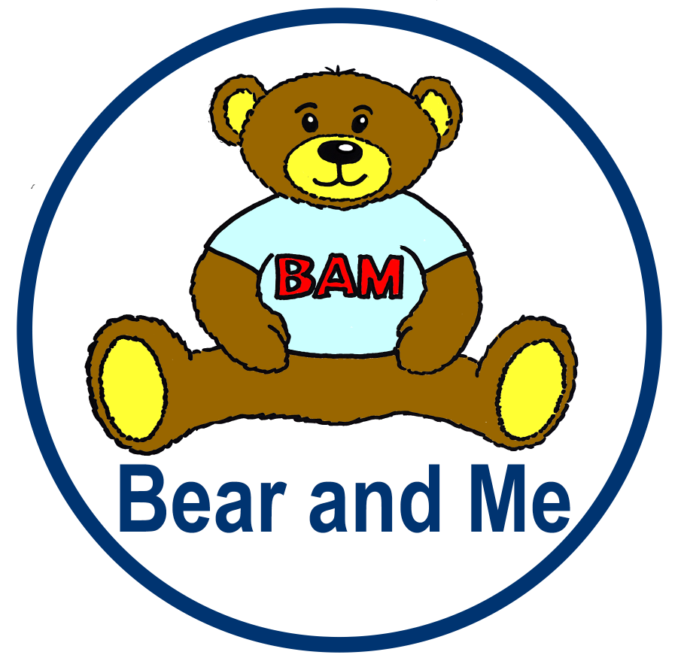

B.A.M
Bear and Me

Would you like to send a Teddy Bear and a Personal diary to your child or children?
B.A.M is a new exciting way to stay in touch with your family.
During this uncertain time your family will have the added pressure of being worried about you. It can be hard to explain prison, particularly to younger children. They often worry that it is a scary place and they are concerned for your safety. Although times are hard now, there have been moments during your sentence where you have engaged in positive activities. We want you to share these stories with your children, so that they can understand your world a little more, and worry a little less.

How to get involved.
There is no charge for B.A.M we will provide the materials you need.
With guidance from the sample diary you will fill in your own personal prison diary – including if you like, any of the photos we have sent to you. Once your diary is complete you return it to the education department. We then send off your diary with a Harry Bear to your family.

The diary is checked by staff before it leaves, we need these to be positive stories for the children and appropriate things to send out. You can draw your own images if you like too but at this time you can’t add any photos you may have of your own, just the ones we send to you to use of Harry bear.

Sample Diary – Here are some ideas for how you can use the diary.

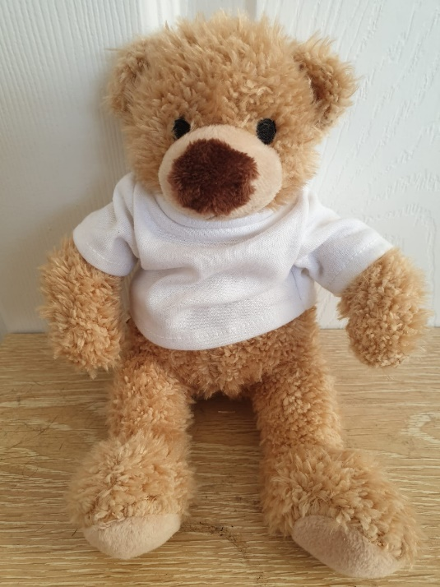
Hi Tom and Daisy,
I’ve sent this Harry bear to come and live with you. He’s spent some time living with me here at the Mount. This diary shows you all the things me and Harry have done together. I hope it will be nice for you to see what I have been up to.
Harry will live with you now. I hope you have fun together.
All my love Dad.

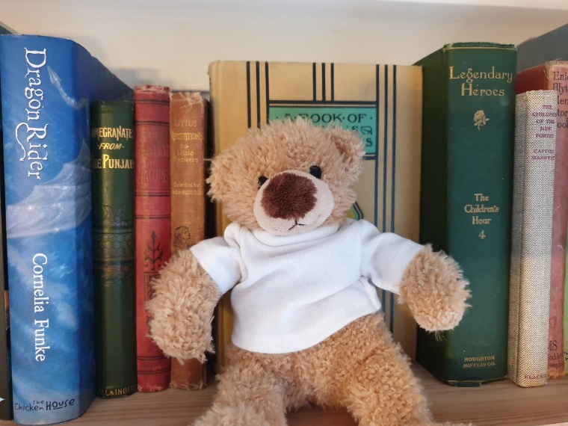
We have a library here. It is one of my favourite places to go. Harry and I go every week to choose new books. My favourite are the fantasy books with dragons and wizards. What books are you reading at the moment?

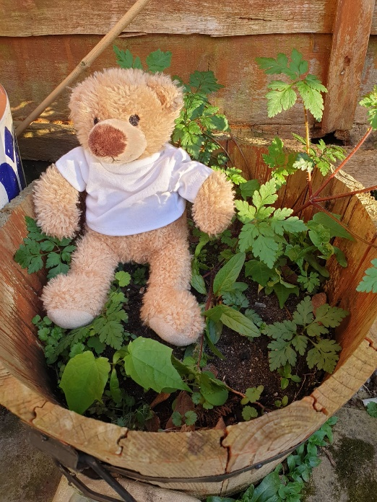
Everybody here is given a job to do. My job is to work in the gardens. I make sure everything is neat and tidy and I am responsible for planting beautiful flowers. As you can see Harry likes to come along and help out. I really enjoy my job in the garden but it is quite tiring. I work in the garden from Monday-Friday so it is nice to have a rest at the weekend and watch some of my favourite TV shows.

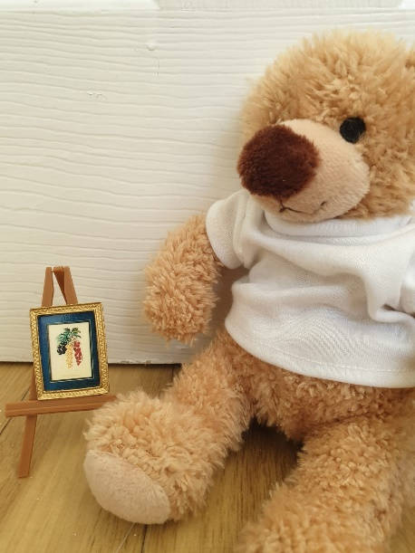
I enrolled on an Art Course here. I really enjoyed it and my paintings are getting better and better. I am quite proud of them – do you like drawing? Perhaps you could draw me a picture to send in next time you write.

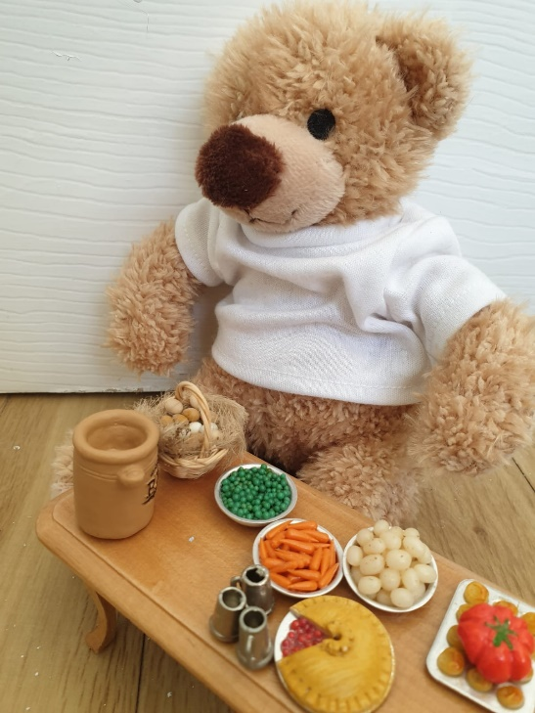
Since coming to stay here I have been doing a lot of my own cooking, although it isn’t as good as the cooking mummy does at home – I am looking forward to having lots of lovely dinner with you when I get home. I hope you are helping mum out with the chores!

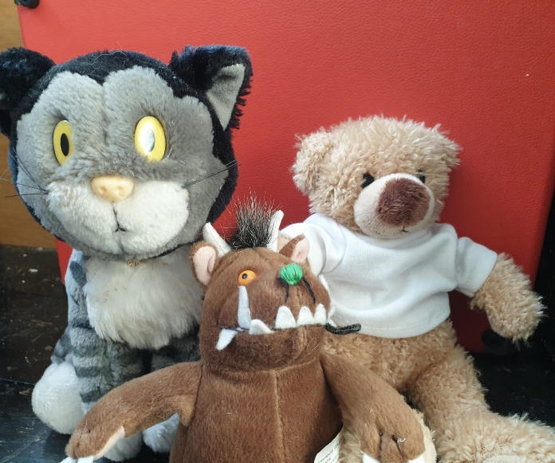
Here is a picture of Harry with some of the friends he has here. Do you recognise any of them? I have made lots of friends here too. My best friend is Luke. He works with me in the gardens.

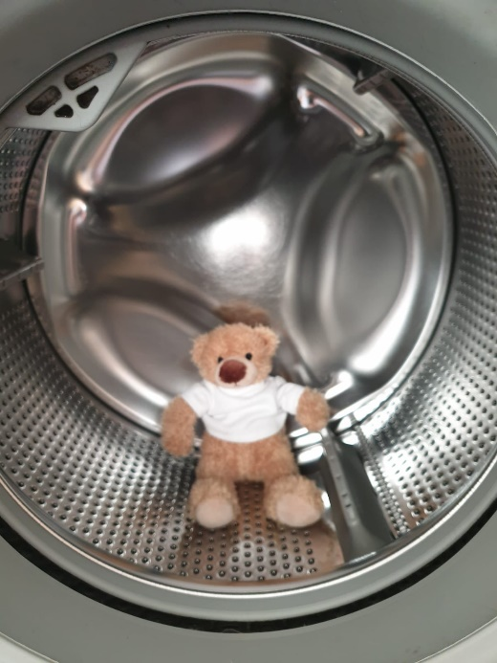
Every Thursday is wash day. Here is a picture of Harry helping me out with the washing!
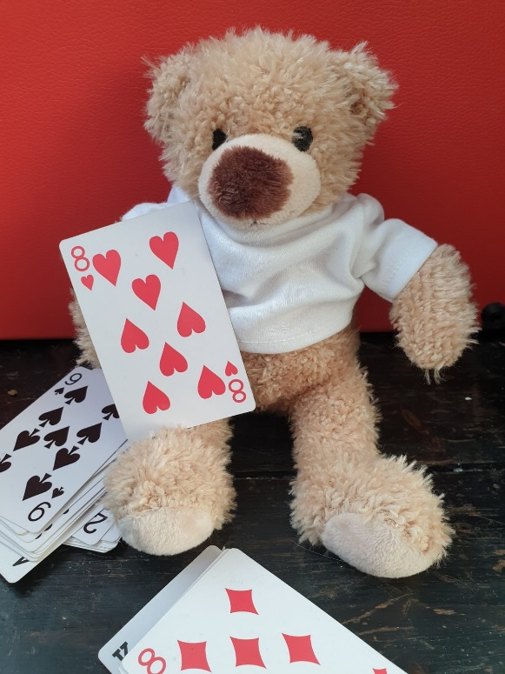
When I am not in the gardens, doing chores or visiting the library I like to play games with my friends here. Harry’s favourite is to play cards but I prefer chess. Nobody else here has ever beaten me at chess!

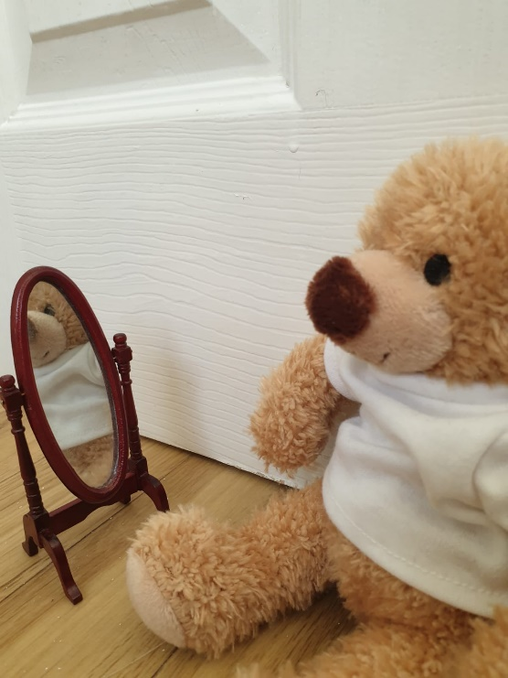
Saturdays are my favourite day because that is when you come to visit me. I know you haven’t been able to visit and I am really looking forward to when you can next come along. I love you very much and wish that it would be sooner but for now we both have to be very brave and wait until we see each other again. Here is a picture of Harry bear getting ready for his visit. He is a funny bear, he spends a lot longer getting ready and looking in the mirror than I do.

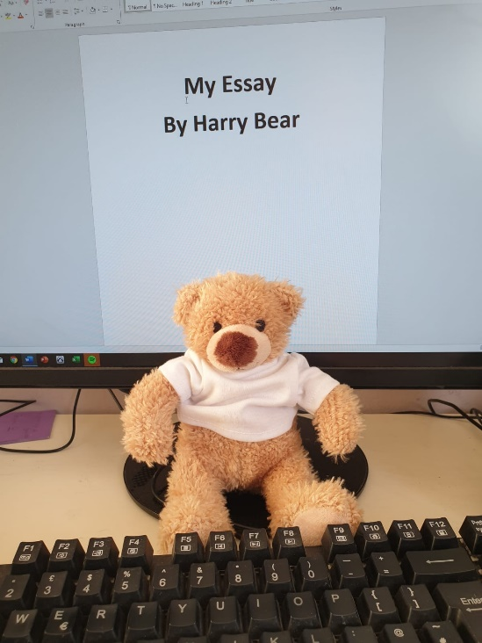
I am also studying hard at the moment. I am studying towards my degree in finance. I spend a lot of time in my room studying and in the library. Maths was also my best subject at school and I am enjoying learning all about finances. What is your favourite subject? Are you missing school?

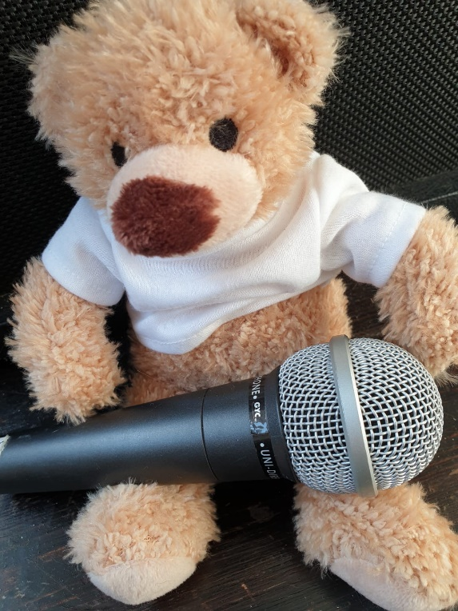
I have just finished my music course here. I enjoyed it a lot. I am looking forward to singing you my songs someday soon. Harry bear enjoys singing so make sure you sing to him sometimes.

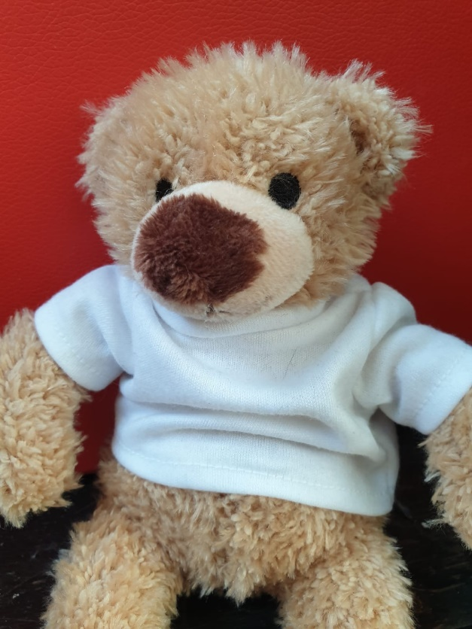
Well kids as you can see, in the time Harry bear has lived with me we have had a lot of adventures. I told him all about you and how much I love you. He said he is looking forward to coming to live with you. Whenever you miss me you can give him a hug. Lots of love Dad x

